15.71: a) 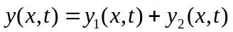
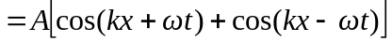
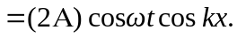
b) At is an antinode. c) The maximum displacement is, front part (b), 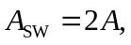the maximum speed is 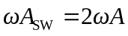and the magnitude of the maximum acceleration is 